SACRED HEART CATHOLIC SCHOOL
DRESS DOWN DAY POLICY 2026 - 2027

To help our students understand how important it is to help those in need, Sacred Heart will sponsor Dress Down Days each month.

Students are permitted to wear shorts, jeans, etc. for $1.00 or dress down top and bottom for $2.00. We will need parental help in ensuring that students are dressed in appropriate “dress down” attire for school. Pajama tops and/or bottoms are not allowed.

Reminder…money is due the morning of our Dress Down Day to their Homeroom Teacher. Please send the correct amount.

The following is acceptable:
Pants: Jeans/Khaki Pants/Capris/Athletic Pants are acceptable. Shorts may be worn; however, length must be no more than 3 inches above the knee (a standard post-it note is a good use of measure.) No holes or rips in clothing. Athletic type shorts are allowed; however, the same length applies. Leggings or skirts are allowed for girls but must be worn with a dress or long shirt that reaches mid-thigh.

Shirts/T-shirts: No sleeveless, spaghetti straps, strapless, or bare midriffs. No tank tops. No inappropriate comments or pictures on clothing.

Shoes: Tennis shoes or gym appropriate shoes are required. No boots, clogs, crock style, heels, or wheelie shoes are permitted.

Parents will receive a call to bring proper clothing if the student is dressed inappropriately.

Dress Down Days are listed on the back of this policy.

PLEASE COMPLETE, SIGN, AND RETURN THE ATTACHED CONSENT FORM TO YOUR HOMEROOM TEACHER BY MONDAY, AUGUST 24, 2026. THE CONSENT FORM MUST BE RETURNED TO BE ABLE TO PARTICIPATE IN DRESS DOWN DAYS. THANK YOU.

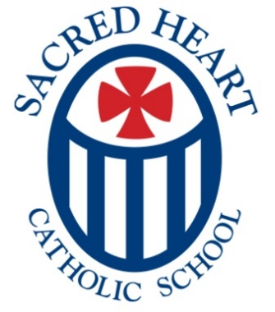
SACRED HEART CATHOLIC SCHOOL
DRESS DOWN DAYS 2026-2027

To help our students understand how important it is to help those in need, Sacred Heart will sponsor a Dress Down Day each month. However, in October, we will sponsor two Dress Down Days to show our extra support for the Rowan County United Way Campaign. The Rowan County United Way supports many different charitable agencies in Rowan County.

Students are permitted to wear casual pants or shorts for $1.00 or dress down top and bottom for $2.00. (Pajama tops and/or bottoms are not allowed.) Money is due to the student’s homeroom teacher the morning of the Dress Down Day. A Dress Down Day Policy Permission Form must be on file in the school office to participate in Dress Down Days. Please see other side for Dress Down Guidelines.

We appreciate your support in ensuring that your child is dressed appropriately for Dress Down Days.

Dress Down Days for Charity:
Friday, Sept 4 Pregnancy Support Center
Friday, Oct 2 Rowan County United Way
Friday, Oct 16 Rowan County United Way
Friday, Nov 6 Thanksgiving Baskets for SHCC and RHM
Friday, Dec 4 Food for Thought
Friday, Jan 8 Priest Retirement Fund
Friday, Feb 5 American Heart Association – In Memory of Lillie Edwards
Friday, Mar 5 Catholic Charities Foundation
Friday, April 16 Meals on Wheels of Rowan County
Friday, May 7 Wallace Cancer Institute



